Balmore Kindergarten Menu – Week

 | Monday | Tuesday | Wednesday | Thursday | Friday
Lunch choice 1 | Chicken & Rice soup  With a Sandwich | Chicken & Rice soup With a Sandwich | Chicken & Rice soup  With a Sandwich | Chicken & Rice soup  With a Sandwich | Chicken & Rice soup  With a Sandwich
Lunch choice 2  (vegetarian option) | Quorn Pasta Bolognese with carrots and Garlic bread  Fresh Fruit and yoghurt | Quiche and Mix Vegetables  Fresh Fruit and yoghurt | Quorn Cowboy Pie’s with mixed vegetables  Fresh Fruit and yoghurt | Bake potatoes with mix toppings (cheese, tuna, beans)  Fresh Fruit and yoghurt | Pizza/ Tomato Pasta and mix Vegetables  Fresh Fruit and yoghurt
Afternoon snack | Fresh Fruit  &  Banana Loaf | Fresh Fruit  &  Cheese cubes & bread sticks | Fresh Fruit  &  Rice cakes | Fresh Fruit  &  Homemade sponge cake | Fresh Fruit  &  Filled sandwiches (ham/cheese)
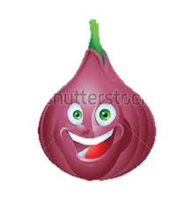
Fresh Milk and Water is offered with all meals and snacks, Water is available throughout the day

