Balmore Kindergarten Menu – Week

 | Monday | Tuesday | Wednesday | Thursday | Friday
Soup of the week | Minestrone  With a Sandwich | Minestrone  With a Sandwich | Minestrone  With a Sandwich | Minestrone  With a Sandwich | Minestrone  With a Sandwich
Lunch choice 1  Lunch choice 2  Pudding | Fish, peas and crispy potatoes  Beans and toast  Ice Lolly  &  Fresh fruit | Chicken Curry  Sweet chilly vegetable rice bowl  Jelly with Fruit | Bangers and Mash with side of Veg  Mac and Cheese  Fresh fruit with Yoghurt | Beef Lasagne with garlic bread & salad  Pizza with garlic bread & salad  Fruit salad | Bake potatoes with mix toppings  Cold meat Platter  Flavoured sponge cake with fruit
Afternoon snack | Fresh Fruit  &  Rice Cakes | Fresh Fruit  &  Filled Croissant | Fresh Fruit  &  Bread Sticks and dips | Fresh Fruit  &  Crackers and cheese | Fresh Fruit  &  Biscuits
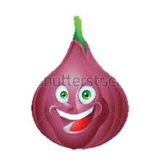
Fresh Milk and Water is offered with all meals and snacks, Water is available through out the day

